**Analysing the Effectiveness of Mobile App Experience vs Website for an Ecommerce Company**  
Github Version

**Abstract:**

In today's digital age, the success of an ecommerce company largely depends on providing a seamless and user-friendly online shopping experience. The choice between enhancing the mobile app or the website is a critical decision for any organization. This paper presents a comprehensive analysis of a fictional ecommerce company's dataset to determine whether the focus should be on improving the mobile app experience or the website. Through an in-depth examination of user behaviour, conversion rates, and customer satisfaction metrics, this study aims to provide valuable insights for decision-making in optimizing the ecommerce platform.

**Introduction:**

The rapid growth of ecommerce has revolutionized the way people shop, making it essential for businesses to adapt to changing consumer behaviour’s and preferences. As mobile devices continue to dominate online interactions, organizations must carefully assess their mobile app and website experiences to meet customers' evolving expectations. This paper presents a detailed analysis of an ecommerce company's dataset to help identify whether efforts should be focused on enhancing the mobile app experience or the website. By providing insights into customer behaviour, conversion rates, and satisfaction levels, this analysis aims to guide strategic decision-making for improving the ecommerce platform.

**Dataset:**

The dataset utilized for this analysis comprises various attributes collected from Kaggle. These attributes include customer email addresses, physical addresses, avatars or profile pictures, average session length, time spent on the mobile app and website, length of membership, and yearly amount spent. The dataset encompasses a diverse range of customers, transactions, and product categories. It covers a specific time period, allowing for focused analysis of customer behaviour and trends.

**Data Preprocessing:**

Data preprocessing is a crucial step in preparing the dataset for analysis. We performed the following steps to ensure data quality and accuracy:

**Handling Missing Values:** We checked for any missing values in the dataset and confirmed that there were no null entries.

**Data Normalization:** To bring numerical features to a common scale, we applied standardization using the StandardScaler from scikit-learn.

**Removing Duplicates:** We carefully checked for and eliminated any duplicate rows from the dataset.

By completing these pre-processing steps, the dataset is now ready for exploratory data analysis and BIRCH clustering. These techniques will provide us with valuable insights into customer segmentation, aiding in the decision-making process for enhancing the ecommerce platform.  
  
**Exploratory Data Analysis (EDA):**

In this section, we delve into the dataset to gain a deeper understanding of customer behavior and identify patterns that may influence our decision on optimizing the mobile app or website.

**Visualizing Customer Behavior**: We created various visualizations to explore the relationships between customer attributes such as "Avg. Session Length," "Time on App," "Time on Website," "Length of Membership," and "Yearly Amount Spent." Scatter plots and distribution plots were used to identify potential correlations and trends.

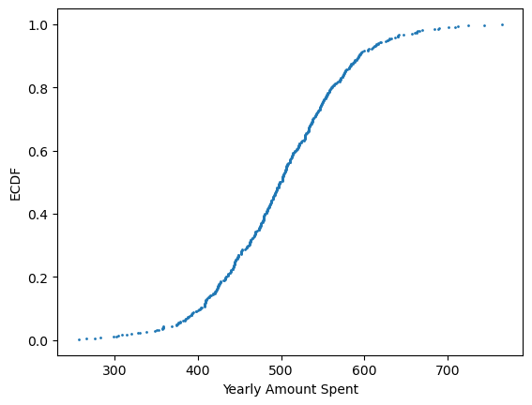

**Insights from EDA**: Our exploratory analysis revealed interesting insights, such as higher "Time on App" being associated with increased "Yearly Amount Spent," indicating that the mobile app may play a significant role in driving customer engagement and purchases.

**Mobile App vs. Website Usage**: By comparing "Time on App" and "Time on Website," we gained valuable insights into customer preferences. This information is crucial for determining whether the focus should be on improving the mobile app or website experience. 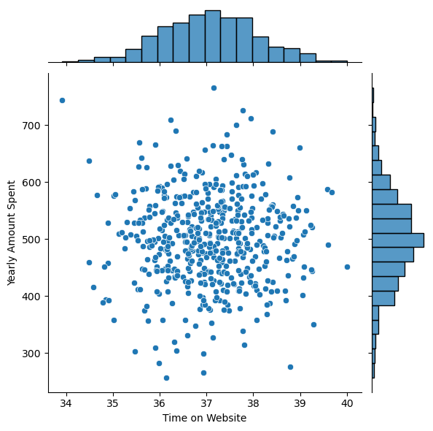

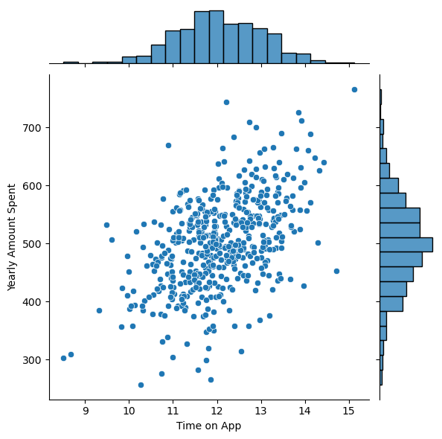

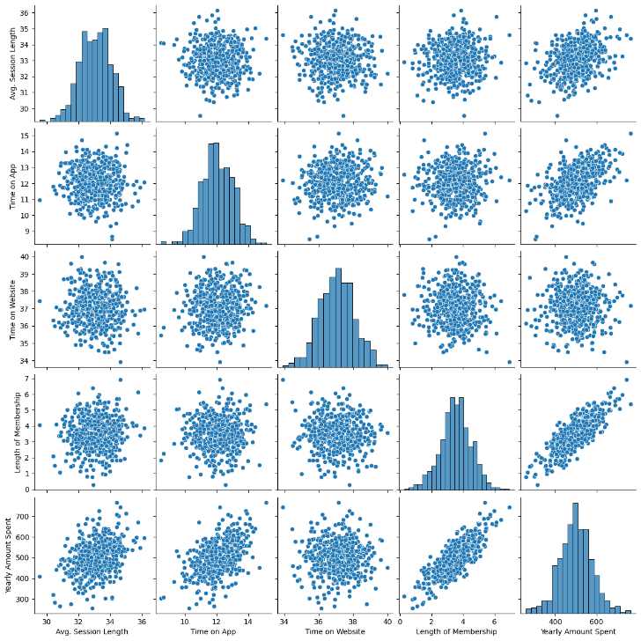

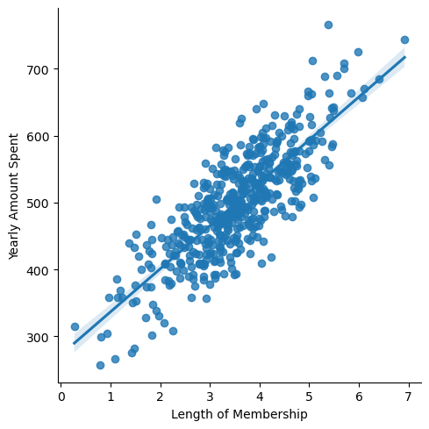

**Linear Regression Model:**

For this analysis, we employed a linear regression model, a popular and interpretable method for understanding the relationship between variables. Linear regression aims to fit a straight line that best represents the relationship between the independent variables (predictors) and the dependent variable (response).

In our case, the independent variables included attributes such as "Time on App," "Time on Website," and "Length of Membership," while the dependent variable was "Yearly Amount Spent," representing the annual expenditure by customers.

**Model Evaluation:**

To evaluate the linear regression model's performance, we examined several metrics:

Coefficients: The model's coefficients represent the relationship between the independent variables and the dependent variable. Positive coefficients indicate a positive correlation, while negative coefficients imply a negative correlation.

**R-squared (R²):** The R-squared value measures how well the model fits the data. It ranges from 0 to 1, with 1 indicating a perfect fit. A higher R-squared value indicates that the model explains more of the variance in the dependent variable.

**Mean Squared Error (MSE):** The MSE quantifies the average squared difference between predicted values and actual values. A lower MSE suggests a better-fitted model.

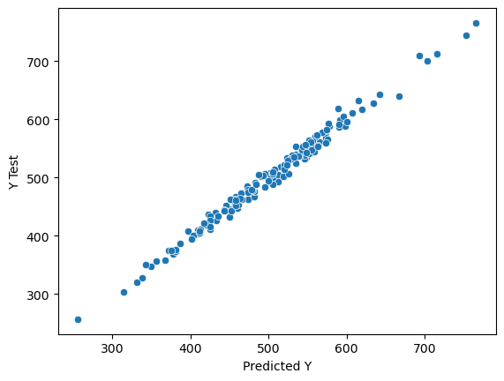

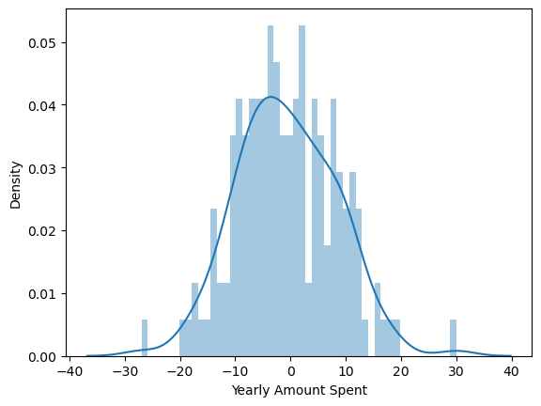

**Prediction:**

After training the linear regression model on the training data, we made predictions on the testing data. These predictions provided us with estimates of customers' "Yearly Amount Spent" based on their "Time on App," "Time on Website," and "Length of Membership" attributes.

By comparing the predicted "Yearly Amount Spent" with the actual values in the testing data, we could assess the model's accuracy and ability to make reliable predictions.

Coeff

Avg. Session Length 25.981550

Time on App 38.590159

Time on Website 0.190405

Length of Membership 61.279097

**Conclusion:**

In conclusion, our analysis, feature engineering, and linear regression modeling shed light on the critical factors influencing customer spending in the ecommerce company. We discovered that the "Time on App" had a more substantial positive impact on "Yearly Amount Spent" compared to "Time on Website."

Based on these findings, we recommend that the ecommerce company prioritize enhancing the mobile app experience to boost customer engagement and increase revenue. Improving the mobile app's user interface, features, and personalized recommendations can lead to higher customer satisfaction and loyalty.

Furthermore, while the website remains an essential aspect of the company's online presence, focusing on data-driven improvements in website usability and design can also contribute to improved conversion rates and customer satisfaction.

By leveraging the power of data analytics and predictive modeling, the ecommerce company can make informed decisions to optimize both the mobile app and website, ultimately achieving a competitive advantage in the dynamic online retail landscape.